Name: ___________________________________ Date: ______________________ Period: _______

**Punnett Squares**

**Complete the Punnett squares based on the information in the pictures, and then answer the questions to the right of each Punnett square.**

**Gray fur**

**1. What percentage of the offspring will have a homozygous recessive genotype? __________**

**2. What will be the ratio of gray fur to white fur in the offspring? __________**

**White fur**

Gg × gg

TT × tt

**3. What percentage of the offspring will have a tall phenotype? __________**

**4. What percentage of the offspring will have a homozygous recessive genotype? __________**

**5. What percentage of the offspring will have white eyes? __________**

**6. What percentage of the offspring will have a heterozygous genotype? __________**

dd × Dd

**7. What percentage of the offspring will have a homozygous dominant genotype? __________**

**8. What will be the ratio of long beaks to short beaks in the offspring? __________**

Ll × ll

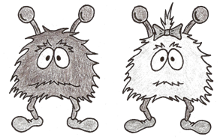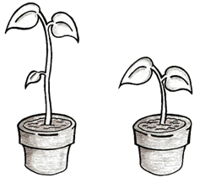

**Tall**

**Short**

**Dark eyes**

**White eyes**

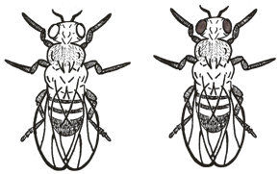

**Short beak**

**Long beak**

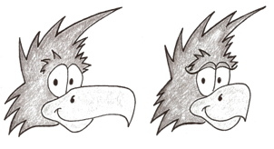

© Haney Science

**9. What percentage of the offspring will have purple flowers as their phenotype? __________**

**10. What percentage of the offspring will have a heterozygous genotype? __________**

pp × PP

**Dark eyes**

**Dark eyes**

**11. What percentage of the offspring will have a heterozygous genotype? __________**

**12. What will the ratio of flies with dark eyes to white eyes be? __________**

Dd × Dd

**13. What percentage of the offspring will be short? __________**

**14. What percentage of the offspring will have a homozygous dominant genotype? __________**

TT × Tt

**Tall**

**Long beak**

**Long beak**

**15. What percentage of the offspring will have long beaks? __________**

**16. What will be the ratio of long beaks to short beaks in the offspring? __________**

Ll × Ll

**Gray fur**

**White fur**

gg × Gg

**Purple flowers**

**White flowers**

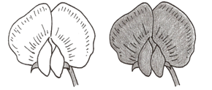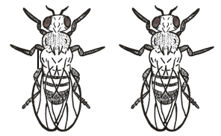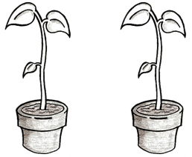

**Tall**

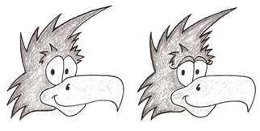

**17. What percentage of the offspring will have the phenotype of gray hair? __________**

**18. What percentage of the offspring will have a homozygous recessive genotype? __________**

